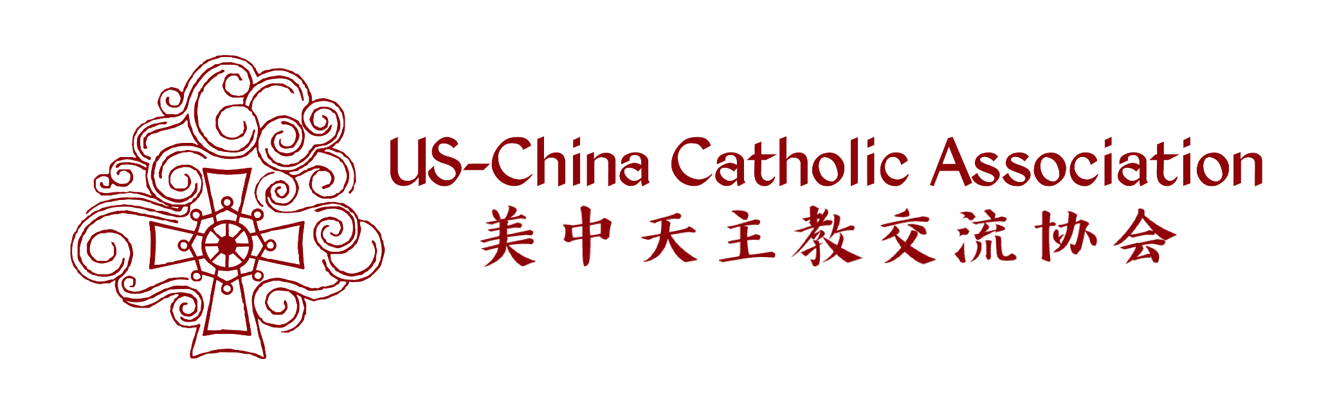

USCCA 2026 CONFERENCE ANNOUNCEMENT
AND CALL FOR SUBMISSIONS
30th Biennial Conference
July 31 to August 2, 2026
University of St. Thomas, Houston, Texas
Save a date and call for submissions!

Call for Submissions on the Conference Theme:

"Nourishing Trust and Friendship: Following the Way of Christ"
​Submission Deadline: February 15, 2026

We are calling for you to share your work on promoting friendship, dialogue, and peace between people in China and the USA in your role as intellectuals, community leaders, members of religious organizations, and workers of nonprofit agencies. The work can be broad or fall into any one of the five main topics of:
(a) understanding social and diverse pastoral needs associated with Chinese people in China and the Americas.
(b) sharing the mission of and learning from Chinese Catholic parish communities: priests, religious Brothers and Sisters, as well as ecclesial and lay leadership in the U.S., Canada, and Greater China.
(c) understanding interdisciplinary academic research on Chinese Catholic disciplines such as history, theology, and interfaith dialogue.
(e) gaining insight from anyone in the public sector about faith and nourishing friendships between the U.S., China and Chinese international communities.
(f) sharing and learning from the personal experience and religious faith of Chinese students and young adults.

Submission guidelines:
Please send a 3-page proposal (in English) describing the content, relevance, and possible impact of your presentation. The proposal should include the following information:

Page 1: Your first, middle, and last name; Your affiliation or institution (with website link to your institution); Your professional role and position in your institution; the title of your project/work/presentation; Your mailing address, email address, cell phone number, and personal webpage, if any.
Page 2-3: No more than 1000-word description, single-spaced, 12-point font size, approximately 500 words per page. Please describe both the content and format of your presentation. We encourage interaction with participants for a more lively and engaging exchange and learning.

We may consider a panel submission if you would like to propose two to three speakers dedicated to the same topic or program. Please submit as a ‘package’ with a 3-page document for each speaker. Put all speakers’ documents together into one single file with a cover page indicating that this is a panel submission and the contact information for the corresponding person for this submission. We assume this person would also serve as the “chair” of the panel being proposed.
​
Submission Procedure:
Please send your individual or panel submission file labeled as “USCCA 2026 Conference Submission – your full name” to Anne S. Tsui, the Secretary of USCCA Board at this email address: board@uscatholicchina.org. Please use “2026 conference submission” in the Subject heading of your email.
​
Submission is open now with a final deadline of February 15, 2026. You will be informed of a decision within a month of submission or no later than March 15, 2026.
​
Authors whose work is accepted must register for the conference and present the work in person. Co-authors are acceptable but no substitute by non-authors of the submissions.

Submission Inquiries:
Please send any submission-related inquiries to Anne S. Tsui at this email address: board@uscatholicchina.org. Please use “2026 Conference inquiry” in the subject heading of the email message.
​
Information about the program schedule, keynote speakers and registration process will be forthcoming soon. Please stay tuned.
​
We look forward to your enthusiastic participation in the USCCA’s 30th Conference by submitting your work to share with conference participants and your participation at the conference in Houston, July 31 - August 2, 2026.

We look forward to your participation
On behalf of the USCCA

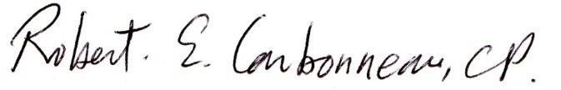

Father Rob Carbonneau, C.P., Ph.D.
Emeritus Director of the USCCA
Email: rcemeritus@uscatholicchina.org
Cell: 443-986-3834
Conference Coordinator of Houston 2026

